Notes on Airflow and Docker

2025-12-30

Here’s a clean way to get Apache Airflow running in Docker from WSL, step-by-step.
I’m assuming:
- You’re on Windows 10/11
- You have WSL2 installed (Ubuntu in your case)
- You’re comfortable with a terminal
If any step already done, just skip it.

1. Make sure Docker Desktop + WSL2 integration is set up (on Windows side)
- Install Docker Desktop for Windows if you haven’t already.
- Open Docker Desktop → Settings → General:
  - Make sure “Use the WSL 2 based engine” is checked.
- Go to Settings → Resources → WSL Integration:
  - Turn on integration for your WSL distro (e.g., Ubuntu).
- Make sure Docker is actually running (Docker whale icon in system tray).
You don’t install Docker inside WSL manually; Docker Desktop exposes it into WSL.

2. In WSL: verify Docker works
In your WSL terminal (Ubuntu):
docker version
docker compose version # or: docker-compose version, depending on install
If you get version info (not “Cannot connect to the Docker daemon”), you’re good.
If you see connection errors, Docker Desktop is either not running or WSL integration isn’t enabled.

3. Create an Airflow project folder (inside WSL)
Pick a directory that’s inside Linux (e.g., under /home/...), not on /mnt/c/... for better performance:
mkdir -p ~/airflow-docker
cd ~/airflow-docker
Note: I decided instead to create in a working directory (not /home/…)
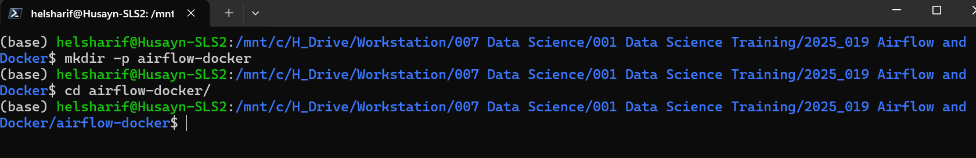

4. Get the official Airflow docker-compose.yaml
From inside ~/airflow-docker:
curl -LfO 'https://airflow.apache.org/docs/apache-airflow/2.10.0/docker-compose.yaml'
If you want a different version, change 2.10.0 to the Airflow version you want, but 2.10.x is current as of late 2025.
You should now have docker-compose.yaml in this folder:
ls
# docker-compose.yaml

I choose latest stable version of airflow (as of 2025-12-30): Version 3.1.5
see: https://airflow.apache.org/docs/apache-airflow/stable/howto/docker-compose/index.html
curl -LfO 'https://airflow.apache.org/docs/apache-airflow/3.1.5/docker-compose.yaml'
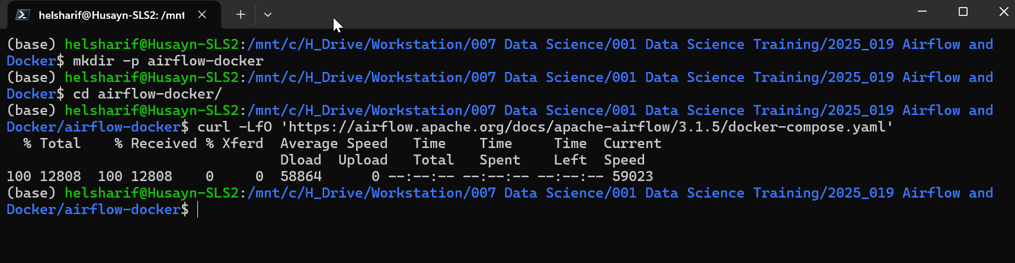

5. Set the Airflow user ID (important in WSL)
Airflow containers need a user ID that matches your local user so file permissions work.
Still in ~/airflow-docker:
echo -e "AIRFLOW_UID=$(id -u)" > .env
You can check:
cat .env
# AIRFLOW_UID=1000 (or similar)
Leave AIRFLOW_UID alone unless you specifically need to change it.
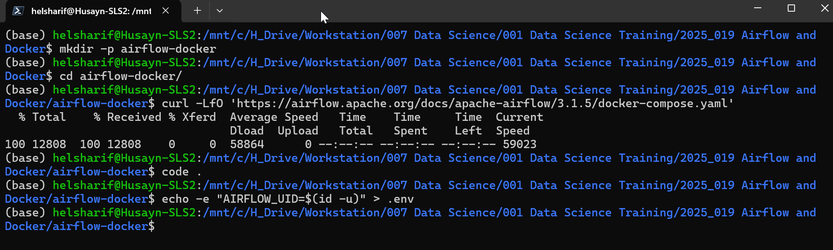

6. (Optional but recommended) Create local dags, logs, plugins folders
Some versions of the example compose file will create these automatically, but it’s nice to be explicit:
mkdir -p dags logs plugins
This is where you’ll put your DAG python files later.
NOTE: AUTOMATICALLY CREATED IN NEXT STEP (So can skip to Step 7 instead of doing Step 6.)

7. Initialize Airflow (DB + user + metadata)
The official docker-compose file defines multiple services, including an airflow-init service that sets up the database and default admin user.
Run:
docker compose up airflow-init
- This will pull the apache/airflow image(s) if you don’t have them yet.
- It sets up the metadata DB, creates default connections/variables, etc.
When it finishes successfully, the container exits. (It’s a one-time init job.)
If you see errors:
- Often it’s file permissions – check your .env has AIRFLOW_UID and that you ran from inside your Linux home, not /mnt/c.
- You can re-run docker compose up airflow-init after fixing.
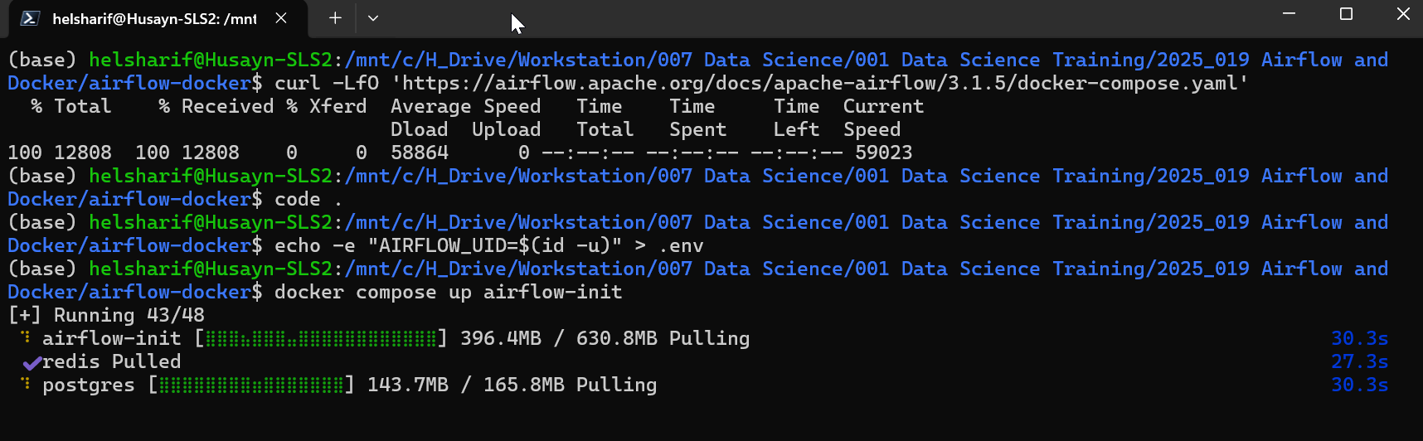

8. Start Airflow (webserver, scheduler, etc.)
Now spin up the whole stack in the background:
docker compose up -d
This will start:
- airflow-webserver
- airflow-scheduler
- airflow-worker (if Celery)
- postgres (default DB)
- redis (if Celery)
- Other helper services defined in docker-compose.yaml
Check that containers are running:
docker compose ps
You should see services with State = running.
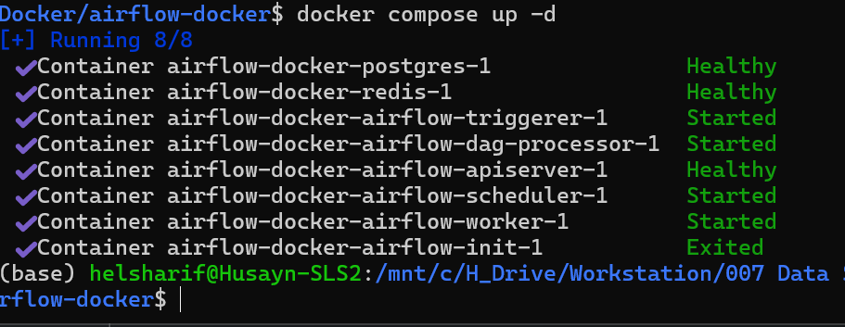

9. Access the Airflow UI from your browser (on Windows)
By default, the docker-compose.yaml exposes Airflow’s webserver on port 8080.
- Open your Windows browser and go to:
http://localhost:8080
Default credentials from the demo compose file (if not overridden):
- Username: airflow
- Password: airflow
(If you changed them in environment variables in the compose file, use those.)

10. Add your own DAGs
Put DAG .py files into the dags/ directory inside ~/airflow-docker (from WSL). Because this folder is mounted into the container, Airflow will detect them automatically.
Example (from WSL):
cp /path/to/your_dag.py ~/airflow-docker/dags/
Then check Airflow UI → DAGs page. After a refresh, you should see your DAG.

11. Common WSL-specific tips
- Use Linux paths, not /mnt/c/..., for your Airflow project to avoid weird permission/performance issues.
- If you see permission errors on logs/, run:
- sudo chown -R $(id -u):$(id -g) .
from inside ~/airflow-docker.
- To view logs:
- docker compose logs -f airflow-webserver
- docker compose logs -f airflow-scheduler
- To stop everything:
- docker compose down

12. Quick recap commands (from WSL)
# 1) Make project directory
mkdir -p ~/airflow-docker && cd ~/airflow-docker

# 2) Get compose file
curl -LfO 'https://airflow.apache.org/docs/apache-airflow/2.10.0/docker-compose.yaml'

# 3) Set UID
echo -e "AIRFLOW_UID=$(id -u)" > .env

# 4) (Optional) Folders
mkdir -p dags logs plugins

# 5) Initialize Airflow
docker compose up airflow-init

# 6) Start stack
docker compose up -d

# 7) Visit http://localhost:8080 in your browser

If you’d like, next step I can:
- Help you tweak the docker-compose.yaml for fewer/more services (e.g., LocalExecutor vs Celery), or
- Show how to mount an extra volume for your PySpark code or course DAGs so they’re picked up automatically.

To shutdown docker-airflow:
docker compose down
To Restart docker-airflow:
docker compose down
docker compose up airflow-init
docker compose up -d

To fully reset docker-airflow:
docker compose down --volumes --remove-orphans
docker compose up airflow-init
docker compose up -d

